# Python HTTP requests task

Your task is to create the following:

- two python web applications with the following properties:

**application 1:**

1. running on port 5000
2. home page with a button/link which takes you to a generate page
3. generation page with route which makes a get request to a route in application 2 for an animal
4. then posts that animal to another route in application 2 which responds with the animal noise.
5. Both the animal and their noise then need to be displayed on the web page.

**application 2:**

1. running on port 5001
2. no web pages displayed
3. animal route which returns the name of an animal in either text or json form
4. noise route which takes a given animal and returns their noise in either text or json form

- these should both be dockerised and should be deployed together with docker-compose

## Solution

## Directory structure and files

The root directory will have:

1. the docker-compose file
2. the directories for application 1 and 2

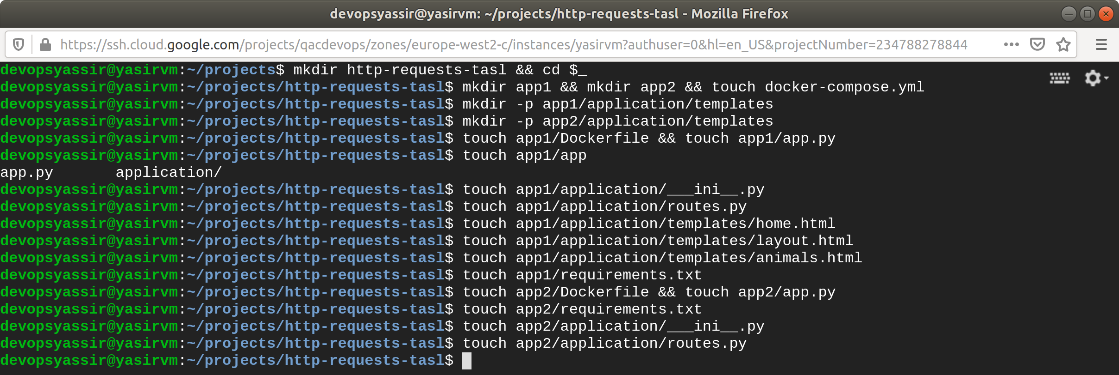

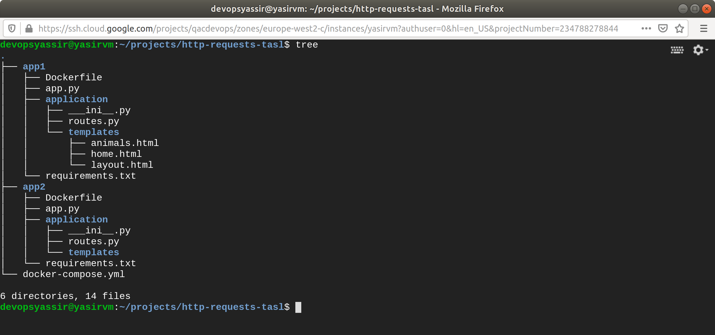

## Create docker-compose.yml

version: '3.7'

services:

flask-app1:

build: ./app1

ports:

- target: 5000

published: 5000

protocol: tcp

flask-app2:

build: ./app2

ports:

- target: 5001

published: 5000

protocol: tcp

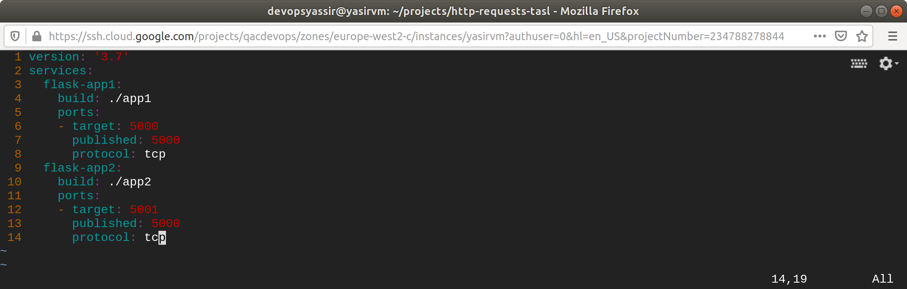

## Create Dockerfile

**app1 Dockerfile**

#Use Python Image

FROM python:3.6.8

# Install apt dependencies

RUN apt update

RUN apt install python3 -y

RUN apt install python3-pip -y

WORKDIR /opt/app1

# Copy contents into image

COPY . ${WORKDIR}

# run pip dependencies

RUN pip3 install -r requirements.txt

# Expose correct port

EXPOSE 5000

# Create an entrypoint

ENTRYPOINT ["/usr/local/bin/python3", "app.py"]

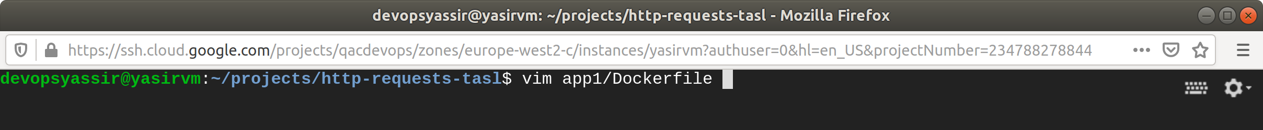

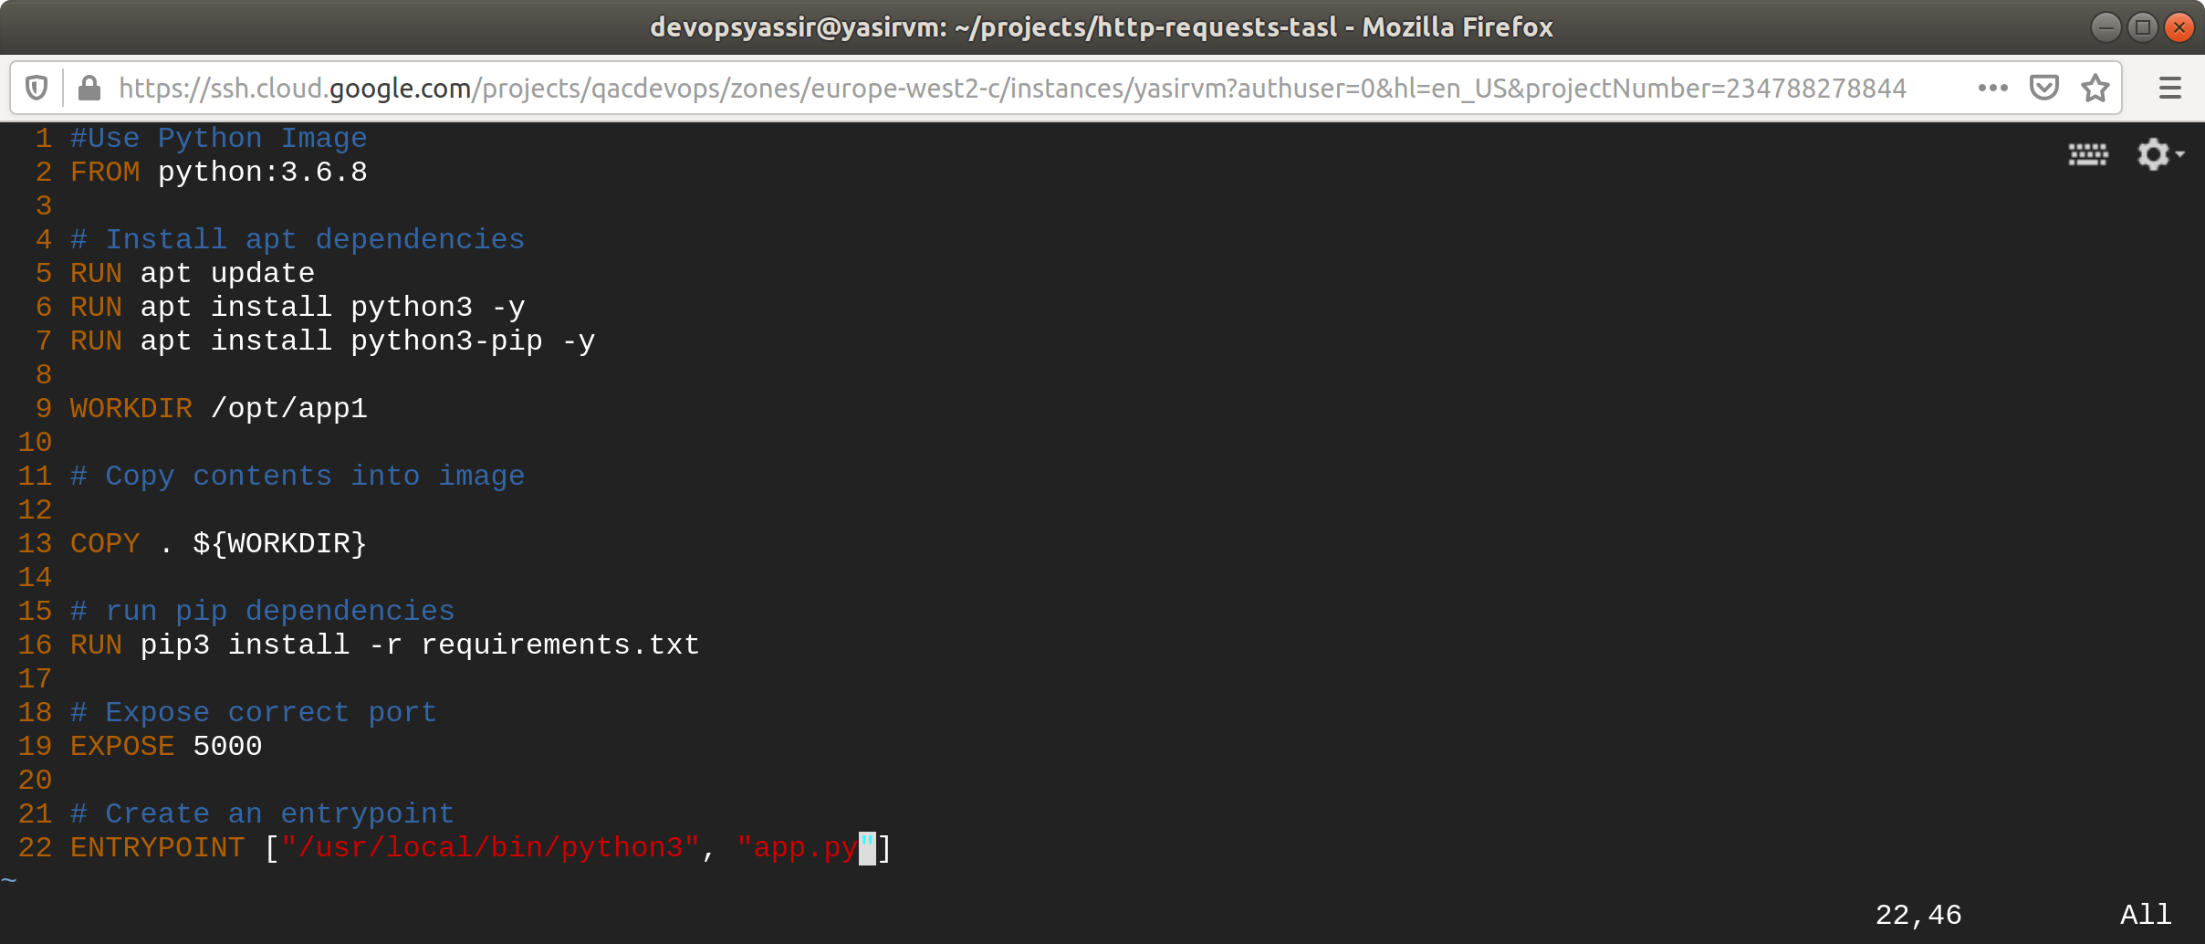

**app2 Dockerfile**

#Use Python Image

FROM python:3.6.8

# Install apt dependencies

RUN apt update

RUN apt install python3 -y

RUN apt install python3-pip -y

WORKDIR /opt/app2

# Copy contents into image

COPY . ${WORKDIR}

# run pip dependencies

RUN pip3 install -r requirements.txt

# Expose correct port

EXPOSE 5001

# Create an entrypoint

ENTRYPOINT ["/usr/local/bin/python3", "app.py"]

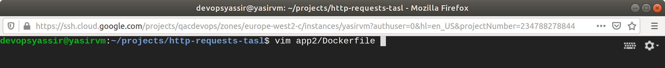

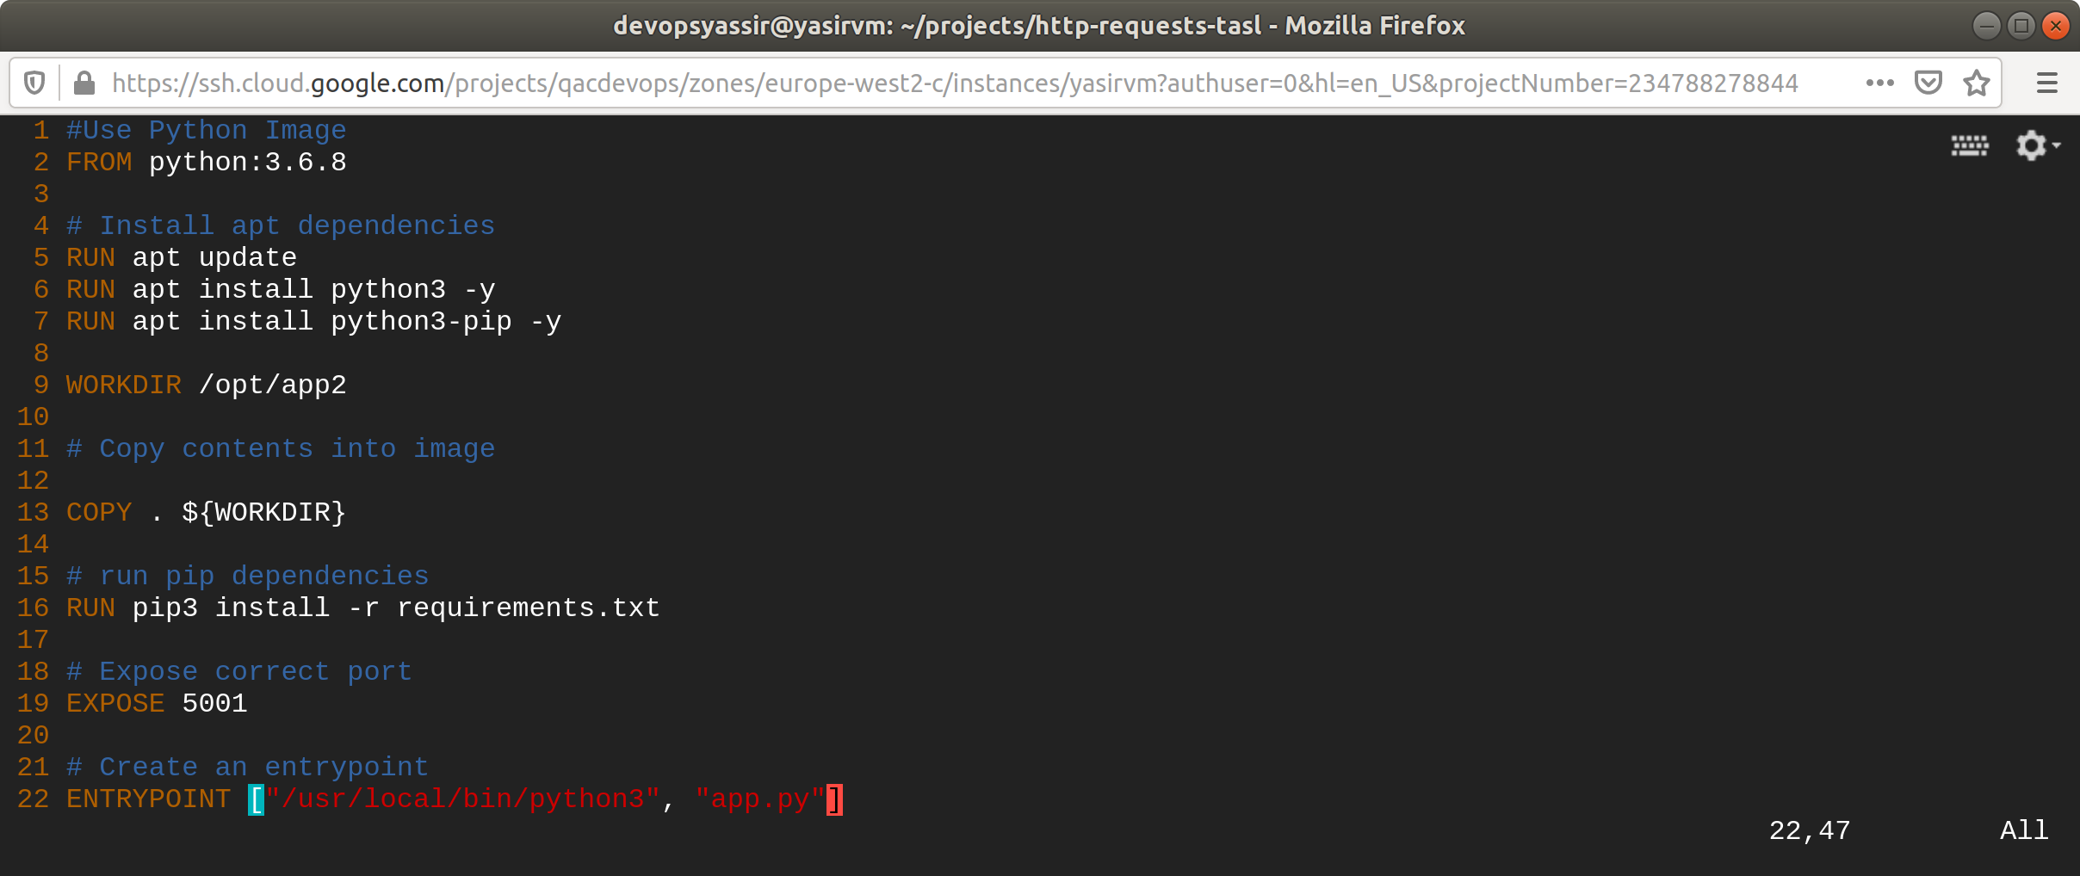

## Create requirements.txt file

same file for boths apps

Click==7.0

Flask==1.1.1

gunicorn==20.0.4

itsdangerous==1.1.0

Jinja2==2.11.1

MarkupSafe==1.1.1

Werkzeug==1.0.0

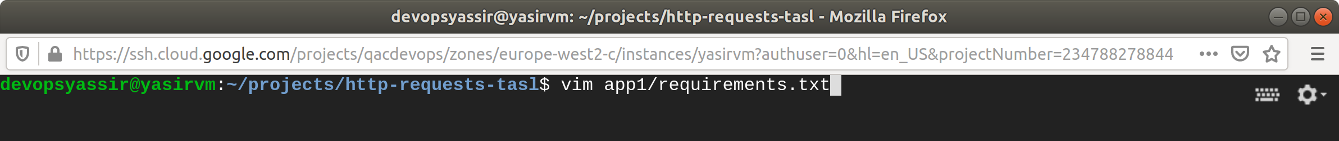

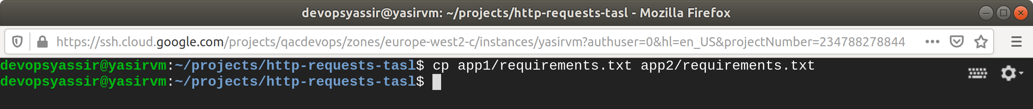

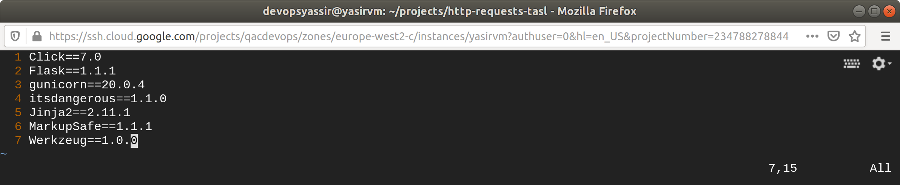

## Create app.py files

**app1**

# imports app object from ./application/__init__.py

from application import app

# if the file is being run directly, and not imported, then start the application.

if __name__ == '__main__':

app.run(debug=True, host='0.0.0.0')

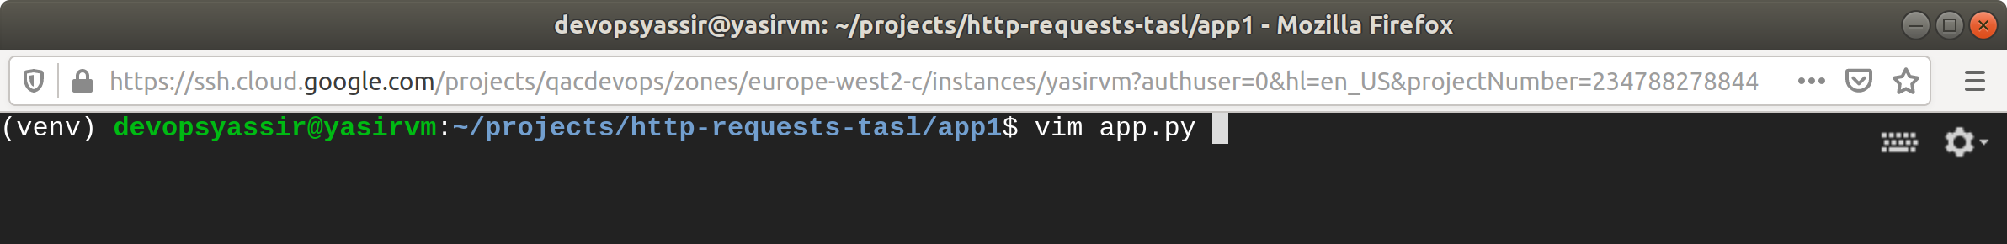

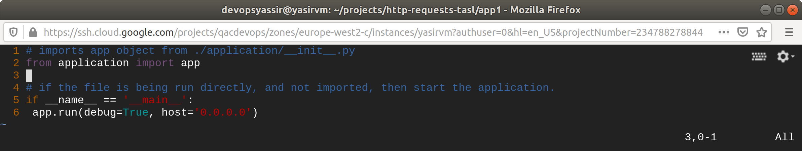

**app2**

# imports app object from ./application/__init__.py

from application import app

# if the file is being run directly, and not imported, then start the application.

if __name__ == '__main__':

app.run(debug=True, host='0.0.0.0')

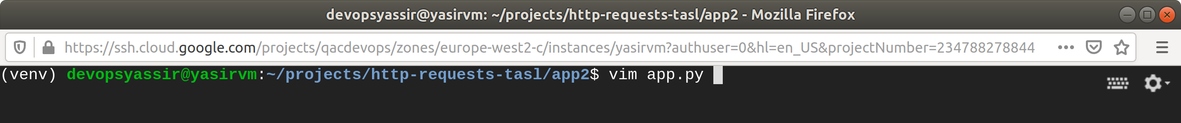

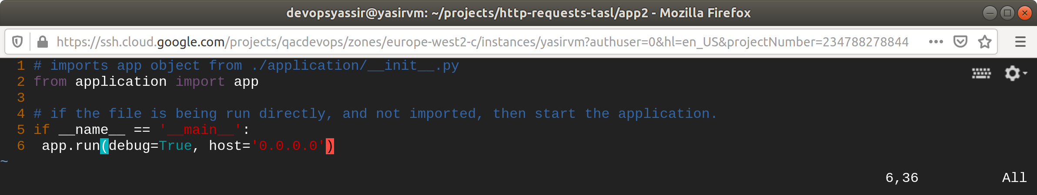

## Create __init__.py files

same for both apps

# import Flask class from the flask module

from flask import Flask

# create a new instance of Flask and store it in app

app = Flask(__name__)

# import the ./application/routes.py file

from application import routes

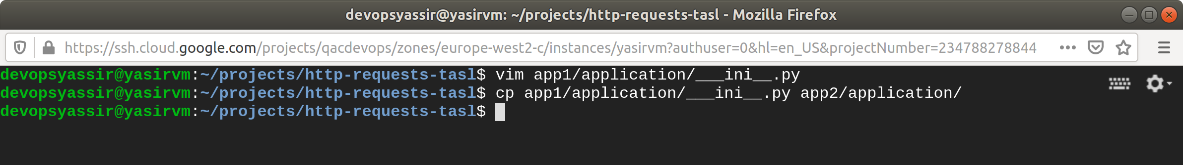

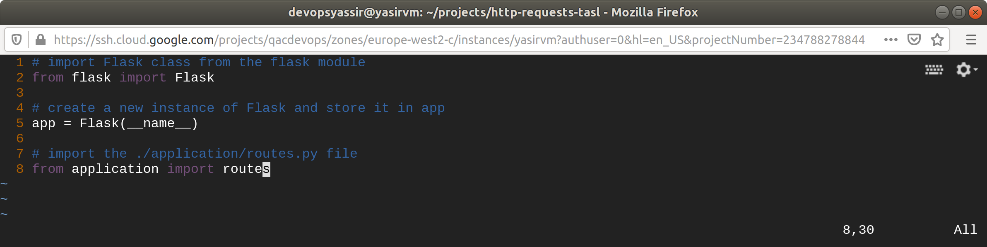

## Create routs.py files

**app1**

# import render_template function from the flask module

from flask import request, jsonify, Response, render_template, redirect, url_for, request

# import the app object from the ./application/__init__.py

from application import app

# define routes for / & /home, this function will be called when these are accessed

@app.route('/')

@app.route('/home')

def home():

return render_template('home.html', title='Home', post=postData)

@app.route('/get/text', methods=['GET'])

def get_text():

return Response('Hello from Flask', mimetype='text/plain')

@app.route('/post/text', methods=['POST'])

def post_text():

return Response("Data you sent: " + request.data.decode("utf-8"), mimetype='text/plain')

@app.route('/get/json', methods=['GET'])

def get_json():

return jsonify({"data": "Hello from Flask"})

@app.route('/post/json', methods=['POST'])

def post_json():

return jsonify({"data": request.get_json()})

**app2**

# import render_template function from the flask module

from flask import render_template, redirect, url_for, request

# import the relevant methods from flask login and your forms

from flask_login import login_user, current_user, logout_user, login_required

# import the app object from the ./application/__init__.py

from application import app, db, bcrypt

from application.models import Posts, Users

from application.forms import PostForm, RegistrationForm, LoginForm, UpdateAccountForm

# define routes for / & /home, this function will be called when these are accessed

@app.route('/')

@app.route('/home')

def home():

postData = Posts.query.first()

return render_template('home.html', title='Home', post=postData)

Create html files

**layout.html**

<html>

<head>

<title>{{ title }}</title>

</head>

<body>

{% block body_content %}

{% endblock body_content %}

</body>

</html>

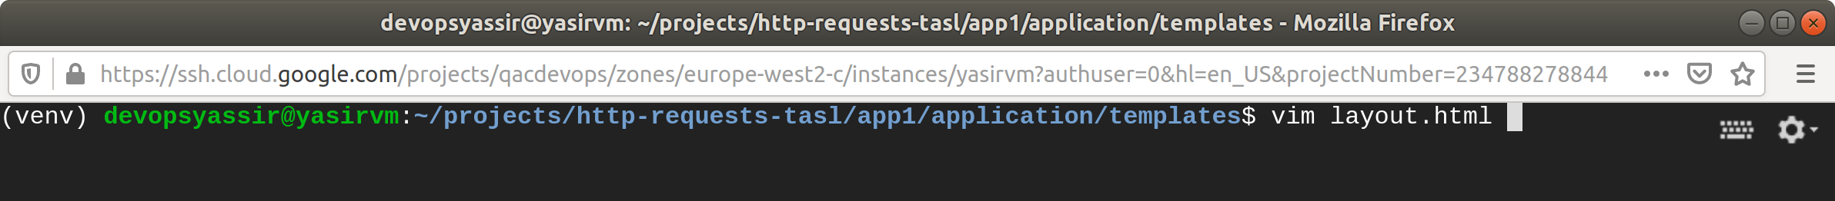

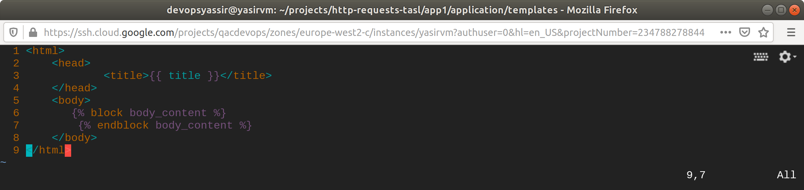

**home.html**

{% extends "layout.html" %}

{% block body_content %}

<h1>Home Page</h1>

<p>Click to generate animal name with its noise sound</p>

{% endblock body_content %}

{% extends "layout.html" %}

{% block body_content %}

<h1>Home Page</h1>

<p>Click to generate animal name with its noise sound</p>

{% endblock body_content %}

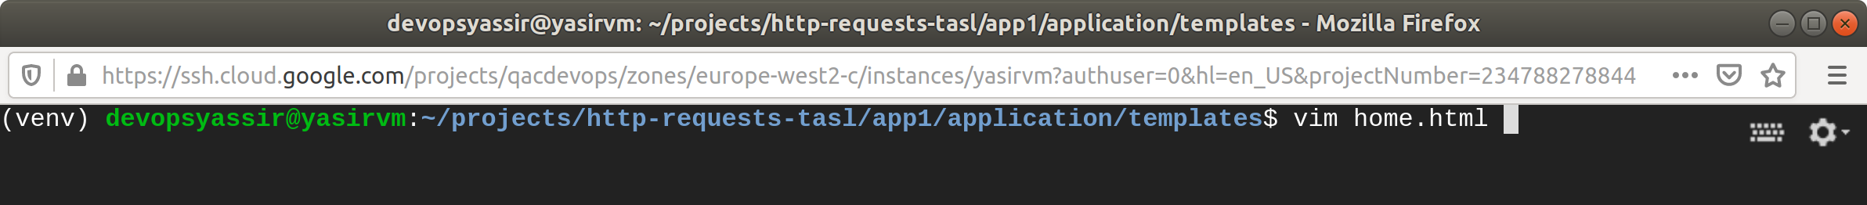

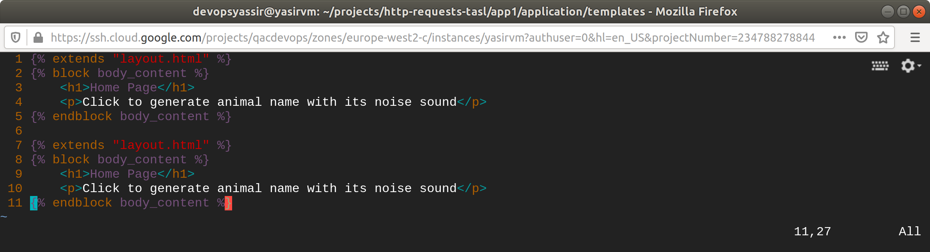

**animals.html**

{% extends "layout.html" %}

{% block body_content %}

<h1>Animals</h1>

<p>Animal and its sound</p>

{% endblock body_content %}

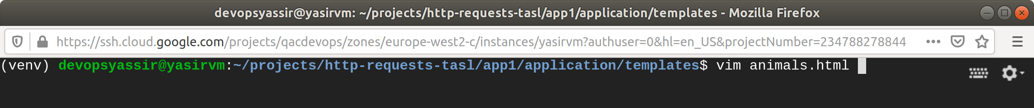

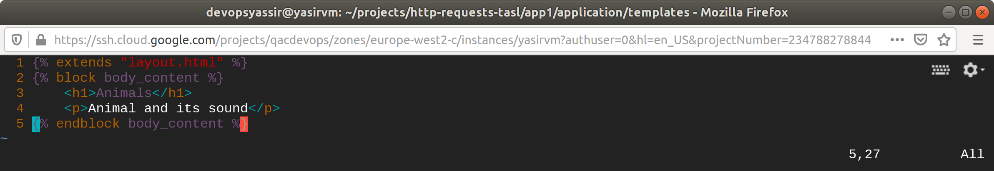

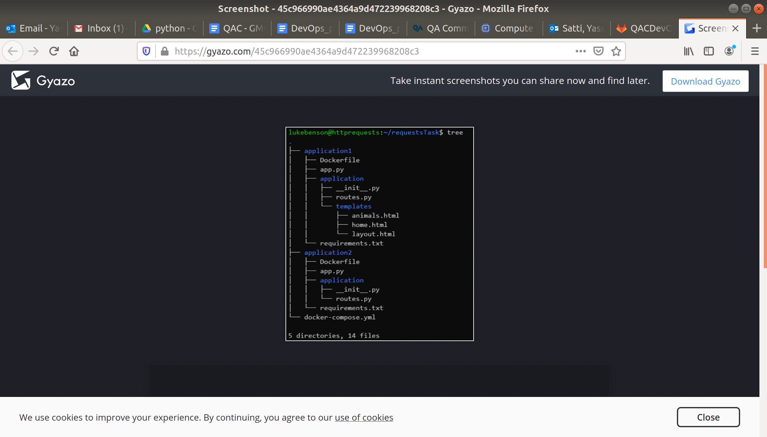

This tutorial will guide through:

* Creating basic Flask application which has several routes to test with the requests library
* Making requests to the various routes on the example Flask application

### **Prerequisites**

* **Fresh Debian/Ubuntu VM**This will help avoid conflicts with any other work that you have been doing.

**Python 3 & Virtual Environment**Neccessary for configuring the Python applications we are building, use this command on a terminal to make sure that they are installed:  
  
 sudo apt update

**$ sudo apt install -y python3 python3-venv**

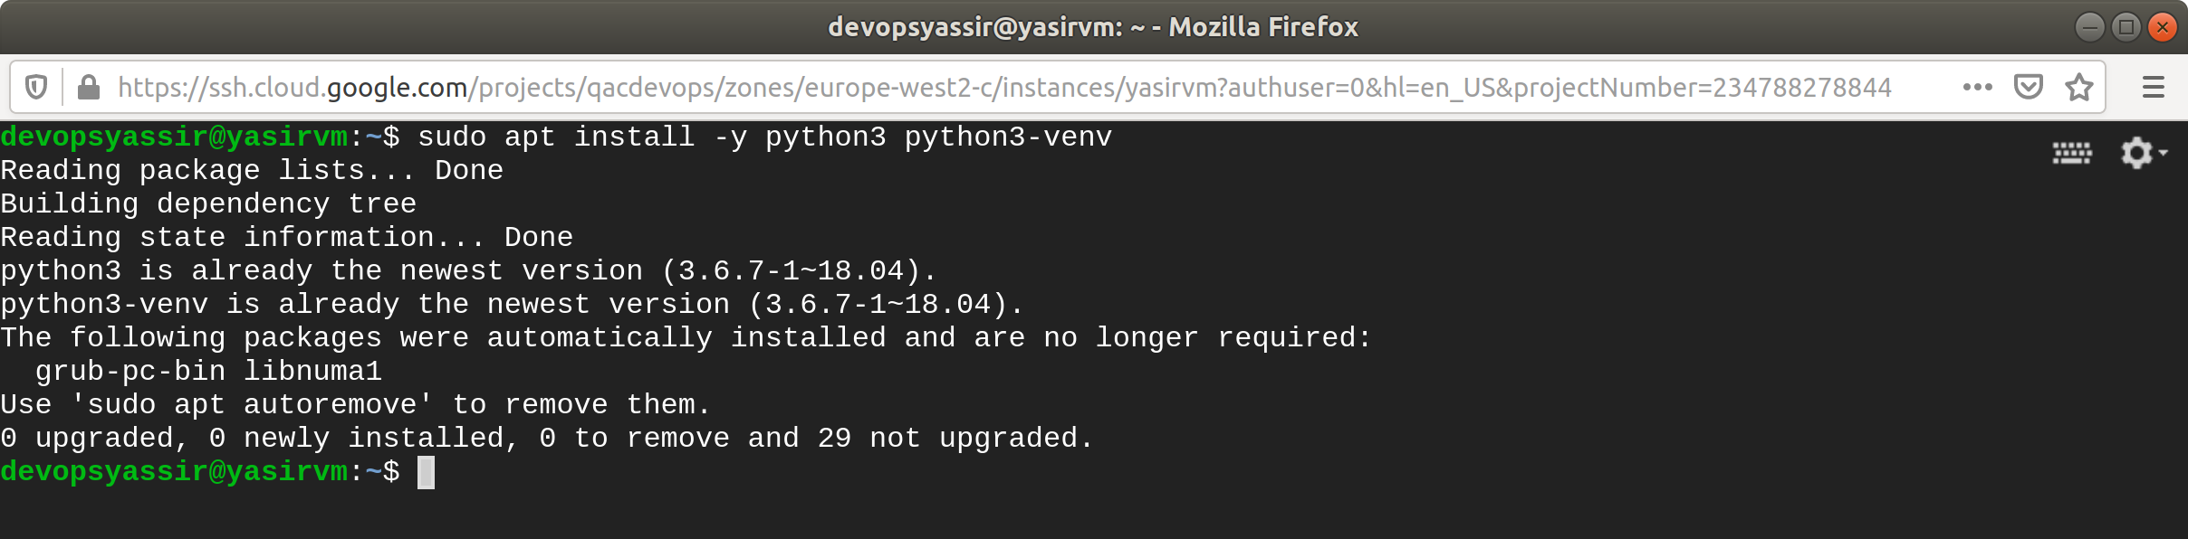

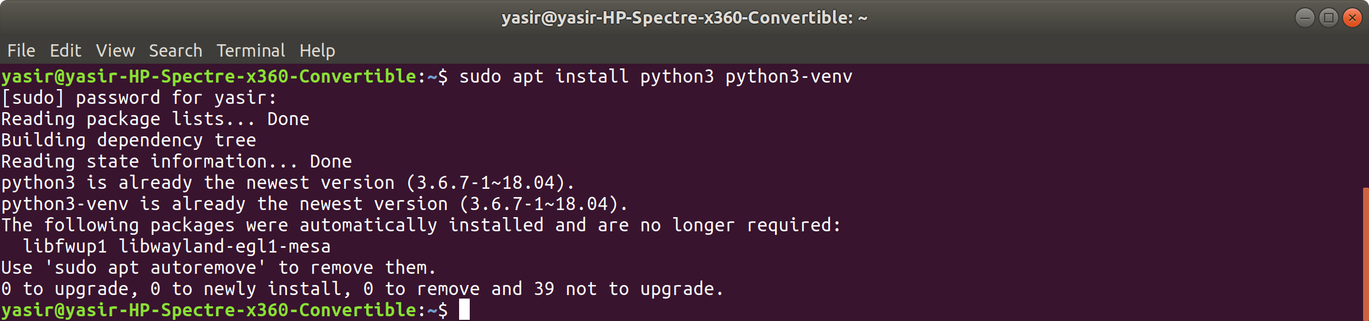

**Git**Git will be needed to download the example API application:  
  
 sudo apt update

**$ sudo apt install -y git**

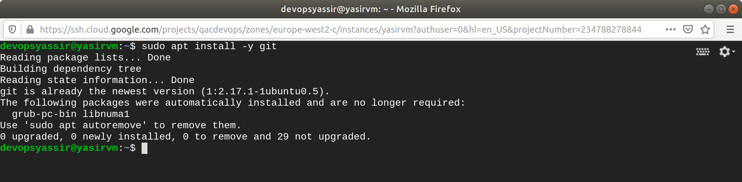

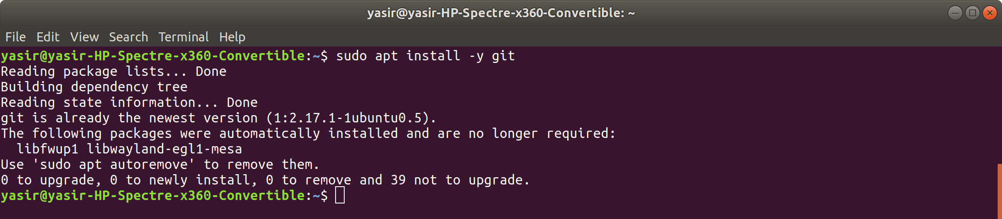

The requests library can be installed using Pip:

**$ pip install requests**

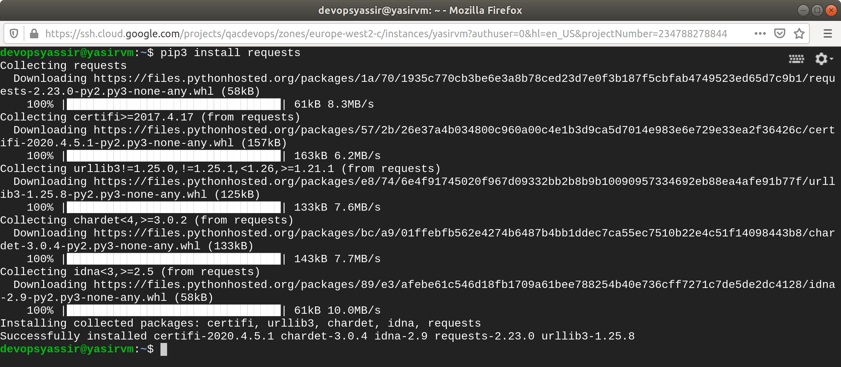

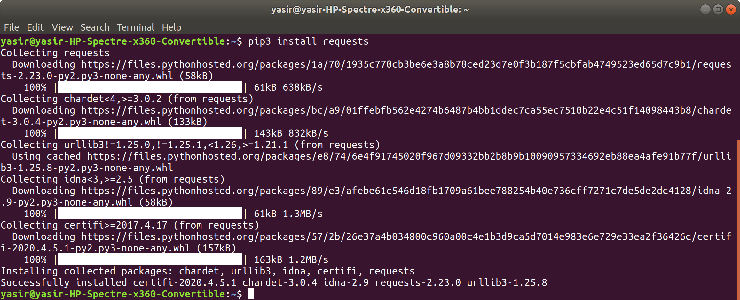

**Example Flask API**To test the requests module an example API Flask Application has been provided.  
It is a very simple application which returns text and JSON responses, feel free to look at the code for this [here](https://gitlab.com/qacdevops/python-flask-example-api).  
Install this API on the VM using these commands:  
  
 **$ mkdir -p ~/projects/gitlab.com/qacdevops && cd $_**

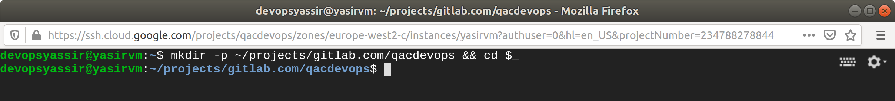



**$ git clone https://gitlab.com/qacdevops/python-flask-example-api**

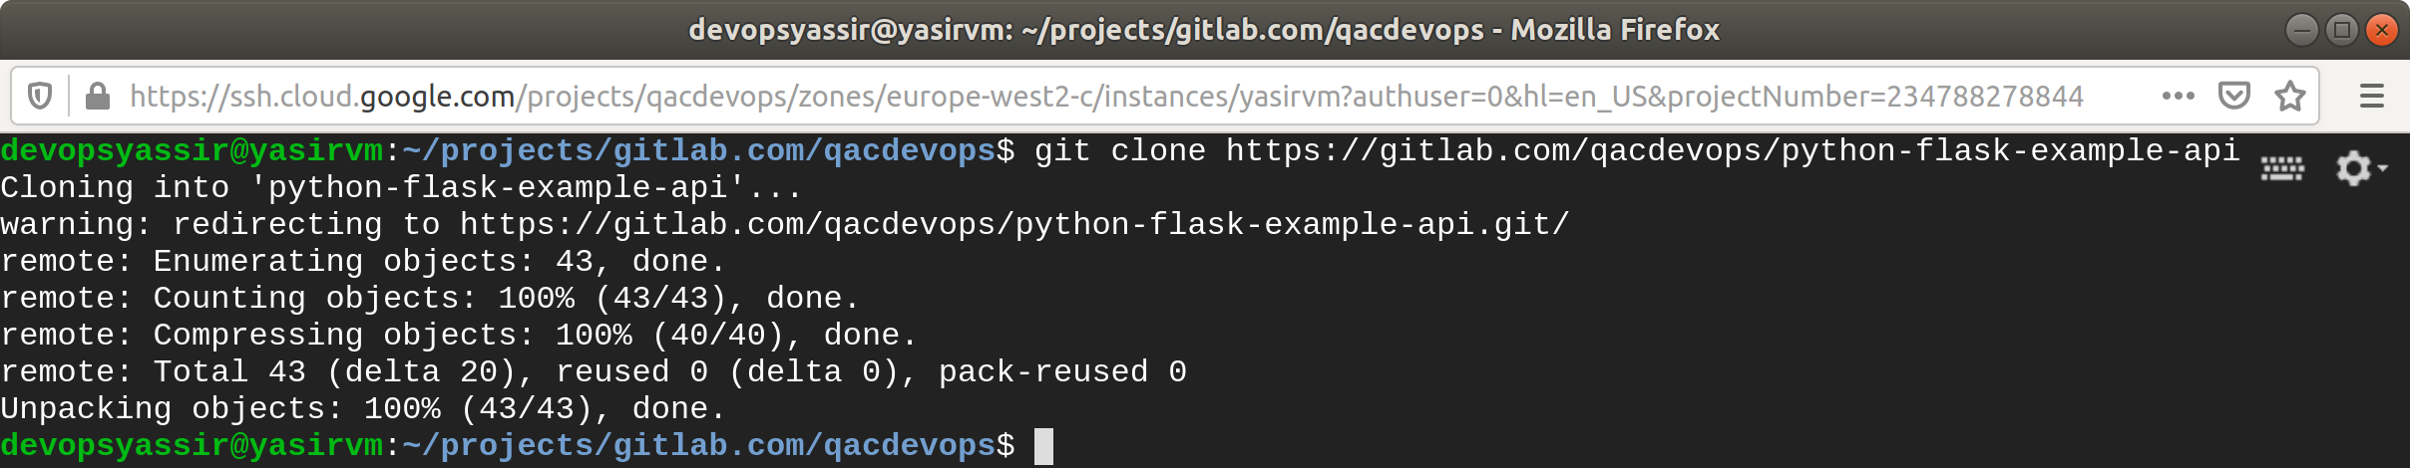

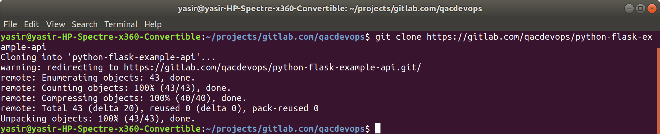

**$ cd python-flask-example-api**

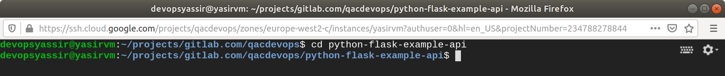



**$ sudo ./hack/deploy.sh**

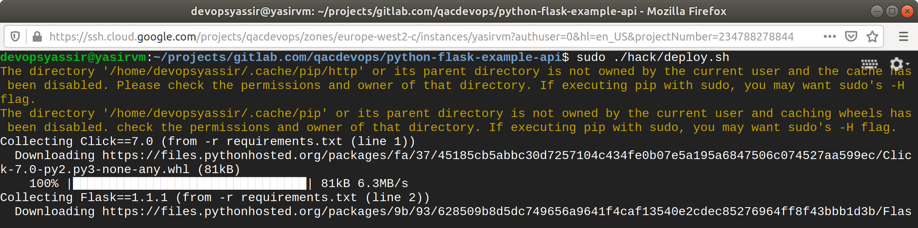

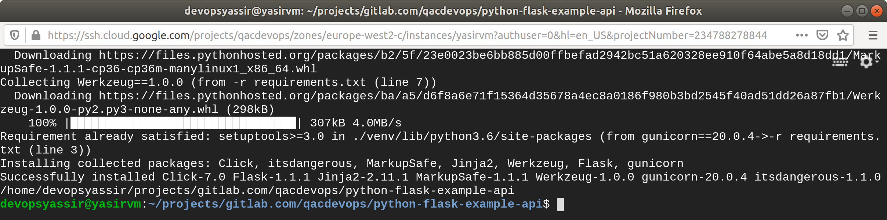

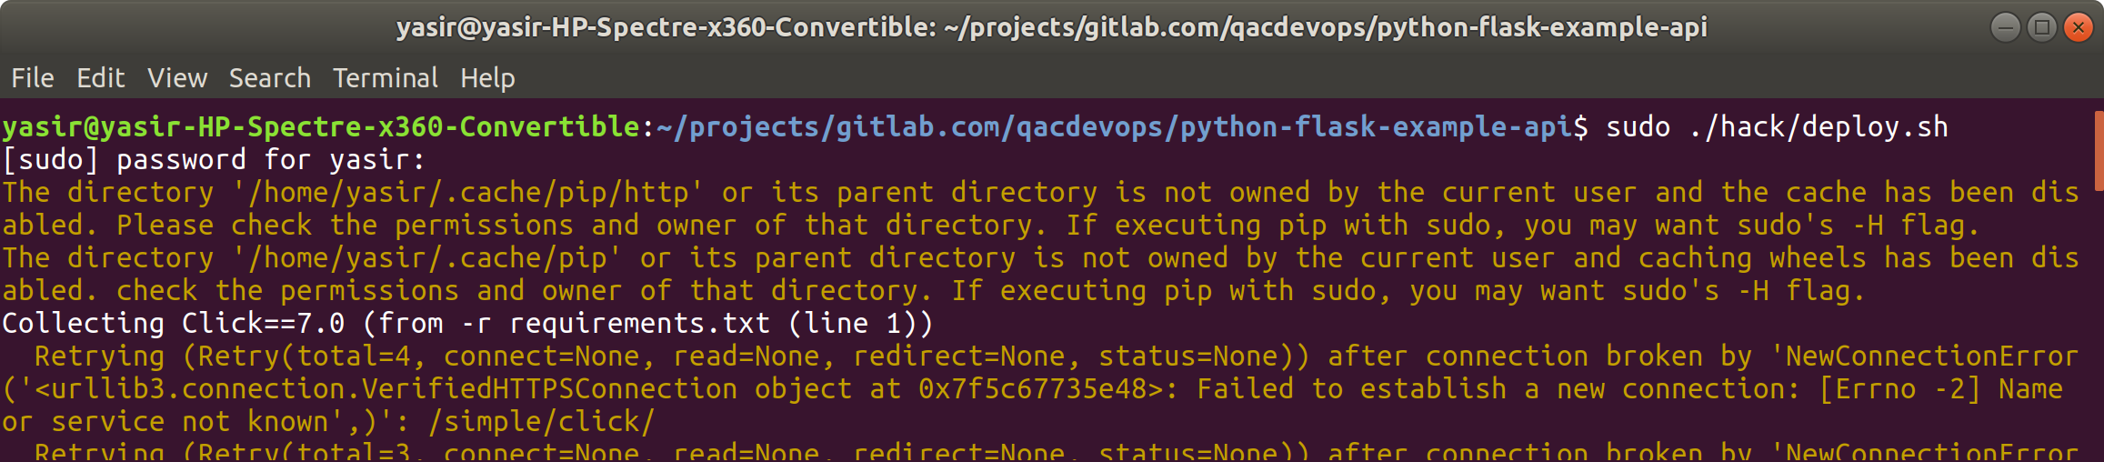

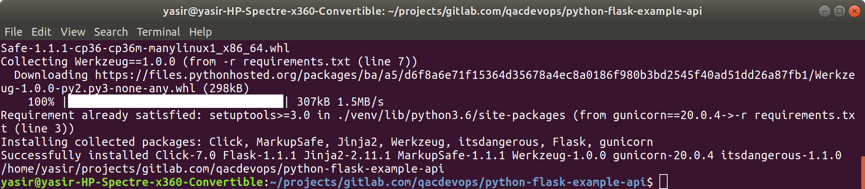

The API setup is running on port 5000 and has the following routes configured:

|  |  |  |
| --- | --- | --- |
| **Route** | **Description** | **Content Type** |
| /get/text | Return a simple text message: *"Hello from Flask"* | text/plain |
| /post/text | Return the data from request back as a part of a string: *"Data you sent: [DATA_YOU_SENT]"* | text/plain |
| /get/json | Return a JSON object containing a data property with a message: {"data": "Hello from Flask"} | application/json |
| /post/json | Return the data from request back as a data property inside of a JSON: {"data": "[DATA_THAT_WAS_SENT]"} | application/json |

### **Setup a Project for Making Requests**

We'll need a project setup now for using the requests library:

**$ mkdir -p ~/projects/http-requests-tutorial/ && cd $_**

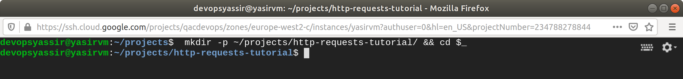

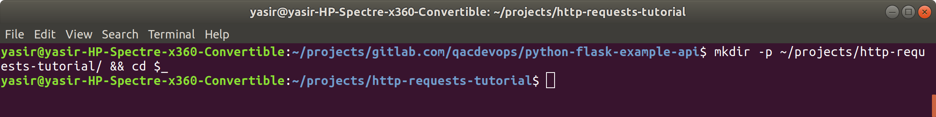

**$ python3 -m venv venv**

**$ source ./venv/bin/activate**

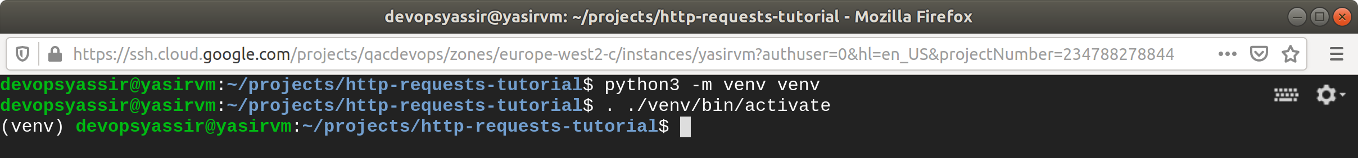



**$ pip install requests**

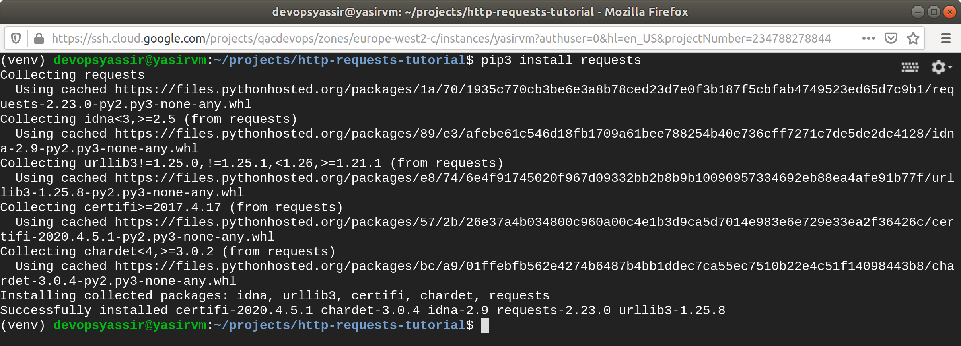

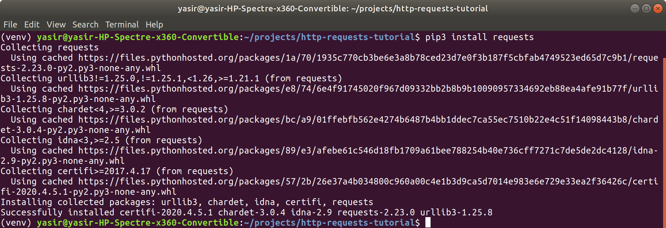

You now a virtual environment with requests installed, create an __init__.py file in this folder and enter the following:

import requests

api = 'http://localhost:5000'

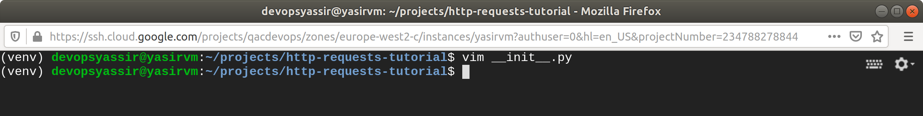

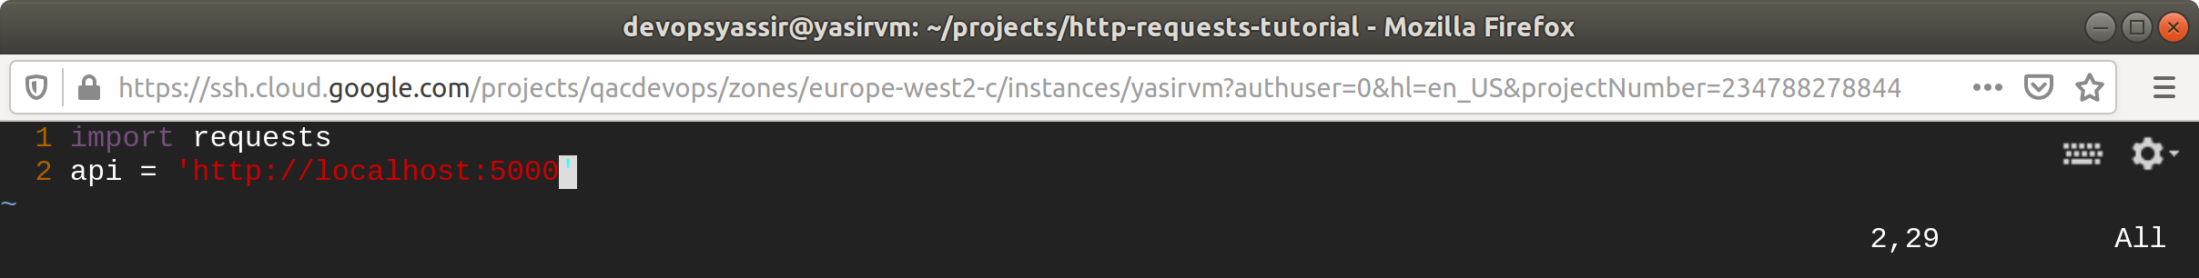

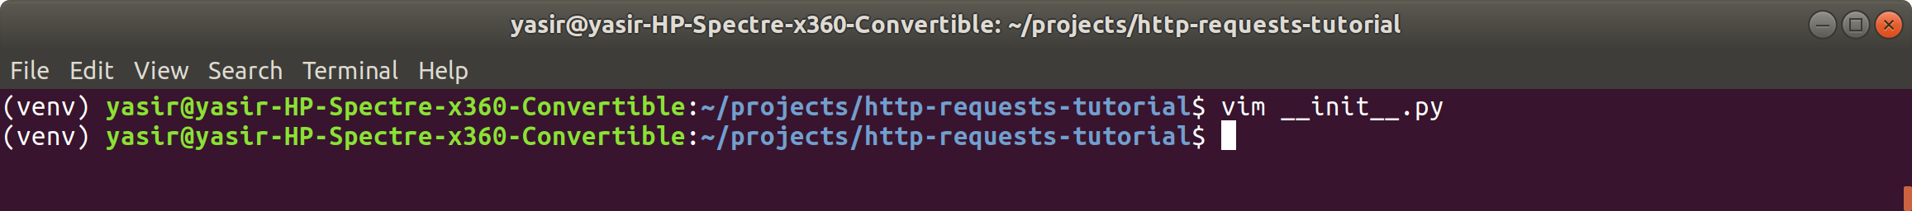

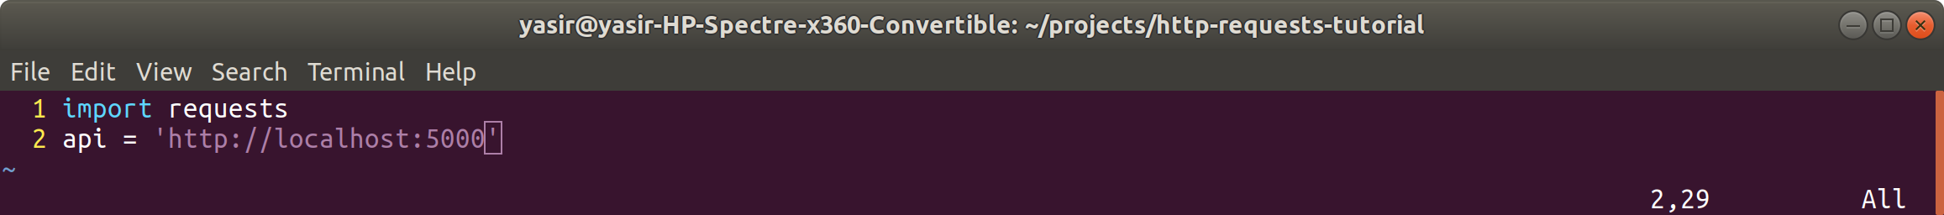

Here we have imported the requests module for making requests and made an api variable so that we aren't going to be repeating ourselves as much on all the requests.

### **Basic HTTP GET Request**

There's a route: /get/text we can create requests for to get a text response, add this to the __init__.py:

print('HTTP GET Request (text):')

response = requests.get(api + '/get/text')

print('Response: ', response.text)

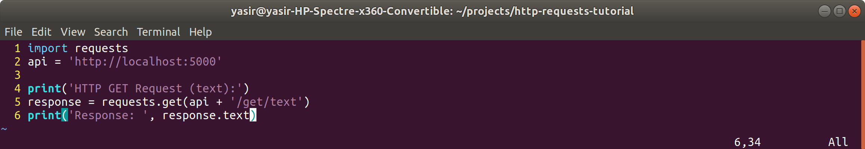

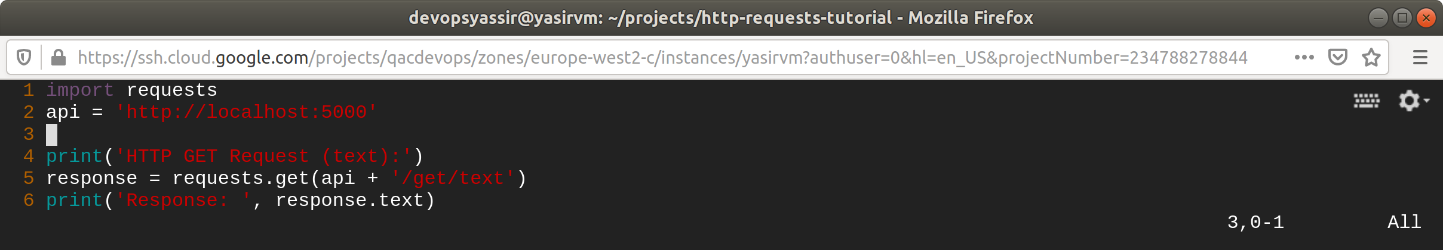

When you run python __init__.py there should be an output like this:

HTTP GET Request (text):

Response: Hello from Flask



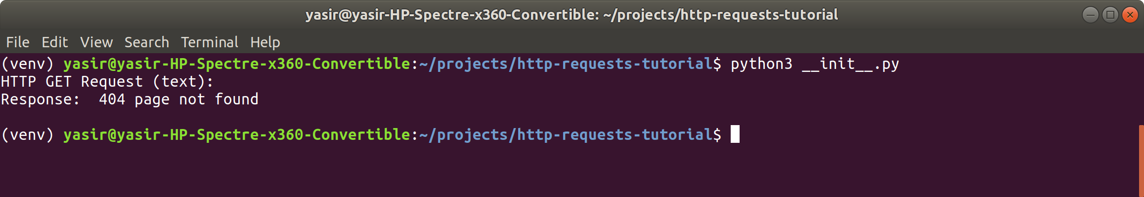

### **Basic HTTP POST Request**

Some text can be sent to /post/text, the response will change depending on the data that you send to it:

print('HTTP POST Request (text):')

response = requests.post(api + '/post/text', 'My Data')

print('Response: ', response.text)

You should see an output like this:

HTTP POST Request (text):

Response: Data you sent: My Data

### **JSON HTTP GET Request**

A simple GET request to /get/json can be made to get a JSON response:

print('HTTP GET Request (json):')

response = requests.get(api + '/get/json')

print('Whole Response: ' + str(response.json()))

print('"data" Property of the Response: ' + str(response.json()["data"]))

You should see an output like this:

HTTP GET Request (json):

Whole Response: {'data': 'Hello from Flask'}

"data" Property of the Response: Hello from Flask

### **JSON HTTP POST Request**

A POST request to /post/json will return a JSON object containing the JSON object that you have sent:

print('HTTP POST Request (json):')

response = requests.post(api + '/post/json', json={"message": "mydata"})

print('Whole Response: ' + str(response.text))

print('"data" Property of the Response: ' + str(response.json()["data"]))

You should see an output like this:

HTTP POST Request (json):

Whole Response: {"data":{"message":"mydata"}}

"data" Property of the Response: {'message': 'mydata'}

